**Create Profile: Inserts user profile**

**URL:** <http://localhost:8080/my-contact-app/api/createProfile>

**Input:**

**{**

**"name":"Bob", "password":"bob", "dob":"1988-10-23", "phone":945235**

**}**

**Method: POST**

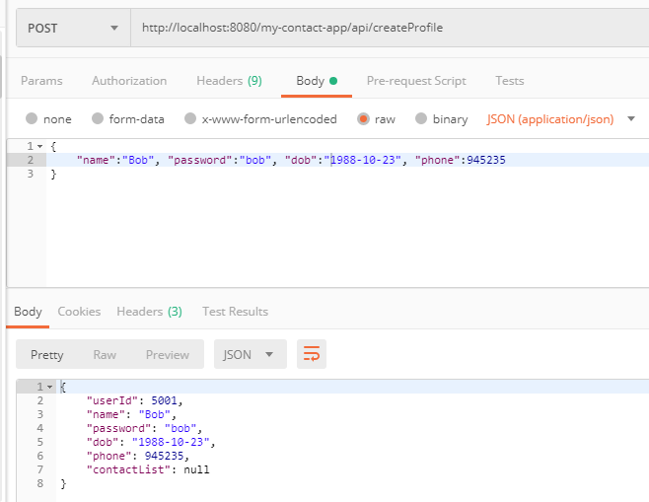

**Add Contacts**

**URL:** <http://localhost:8080/my-contact-app/api/profile/5001/addContact>

**Input**

**{"name":"Sachin", "phone":98374758}**

**Method: POST**

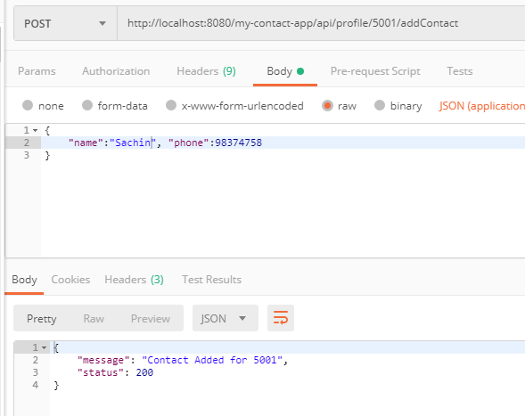

**Search contact for a particular user id**

**URL:** [**http://localhost:8080/my-contact-app/api/profile/5001/David**](http://localhost:8080/my-contact-app/api/profile/5001/David)

**Method: GET**

Expected Output: If contact exists

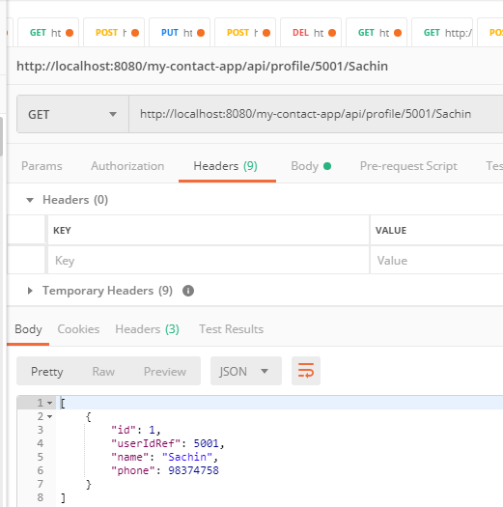

**Expected Output: If contacts not exist**

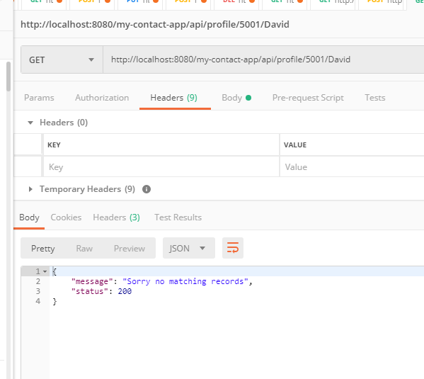

**Get contacts from a particular user**

**URL:** [**http://localhost:8080/my-contact-app/api/profile/5001/contacts**](http://localhost:8080/my-contact-app/api/profile/5001/contacts)

**Method: GET**

**Expected Output: If contacts exist**

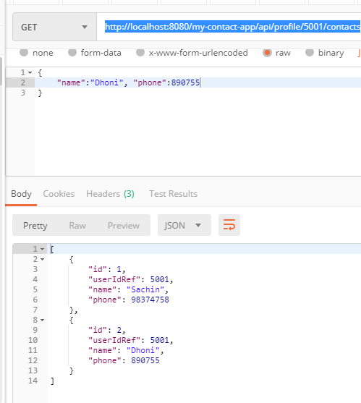

**Expected Output if no contacts or User id is wrong**

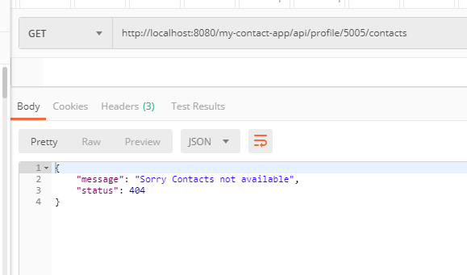

**Authenticate with username & password**

**URL:** <http://localhost:8080/my-contact-app/api/login/5001/bob>

**Method: GET**

**Expected Output if username & password is valid**

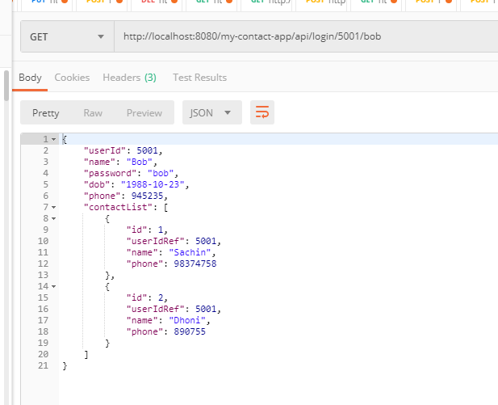

**Expected Output if Username or Password is wrong**

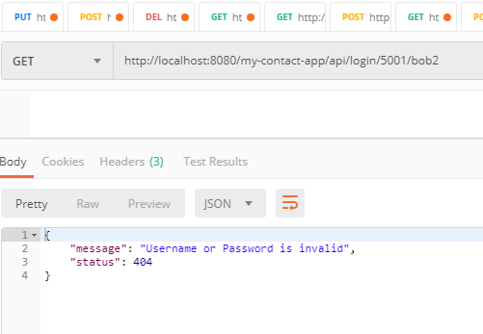

**Update Password**

**URL:** <http://localhost:8080/my-contact-app/api/updateProfile/5001/bob123>

**Method: PUT**

**Expected Output When User is valid**

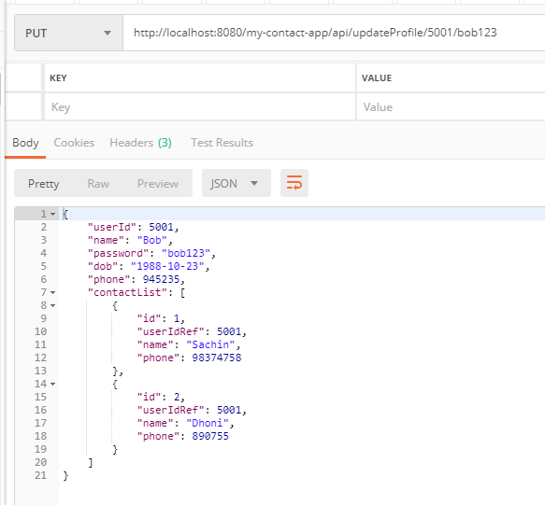

**Expected output for invalid userid**

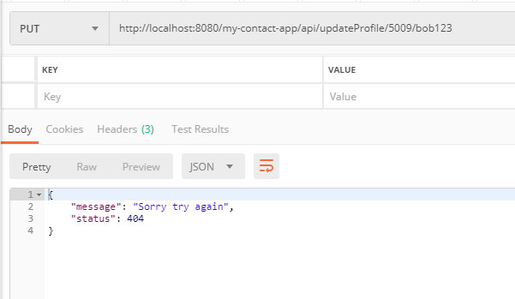

**Delete the contact of a particular userid**

**URL:** <http://localhost:8080/my-contact-app/api/profile/50000/delete/2>

**Method: Delete**

**Expected Output If contact id is correct but userid is wrong  
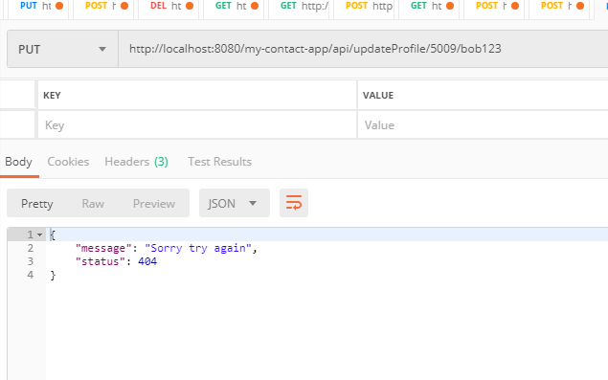**

**Expected output when userid & contact id are correct**

**URL:** <http://localhost:8080/my-contact-app/api/profile/5001/delete/2>

